NAME : K.PRAVEEN KUMAR

ASSIGNMENT-5(08-12-23)

**EQUI JOIN**:

select students.id,students.name,students.class,students.marks,student_grades.grade

from students,student_grades where students.id=student_grades.id;

or

select students.name,students.class,students.marks,student_grades.grade

from students join student_grades on students.id=student_grades.id;

output:

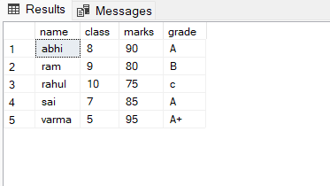

**Non Equi join:**

select students.id,students.name,students.class,students.marks,student_grades.grade

from students,student_grades where students.id<student_grades.id;

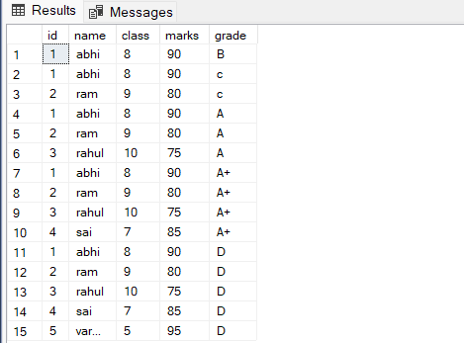

select students.id,students.name,students.class,students.marks,student_grades.grade

from students join student_grades on students.id>=student_grades.id;

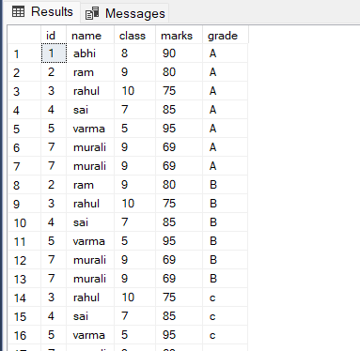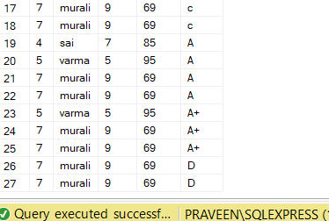

**Exists keyword:**

select name from suppliers

where exists(select Pname from Products where products.supplierID=suppliers.supplierID and price<20);

select name from suppliers

where exists (select Pname from Products where products.supplierID =suppliers.supplierID and price=40);

select name from suppliers

where exists (select Pname from Products where products.supplierID =suppliers.supplierID and price<40);

select Pname from products

where exists (select name from suppliers where products.supplierID=suppliers.supplierID or price>=30);

select Pname from products

where exists (select name from suppliers where products.supplierID=suppliers.supplierID and price>=30);

output:

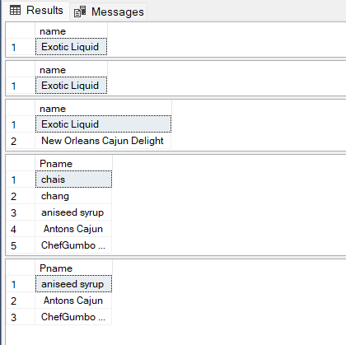

**ANY keyword:**

select * from products

where supplierID <=any(select supplierID from suppliers

where supplierID>'2' );

select * from products

where supplierID =any(select supplierID from suppliers

where supplierID='1' );

select * from products

where supplierID =any(select supplierID from suppliers

where supplierID!='1' );

**output:**

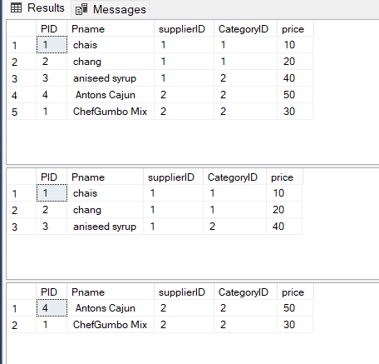

**ALL keyword:**

select * from products

where supplierID =all(select supplierID from suppliers

where supplierID='2' );

select * from products

where supplierID < all(select supplierID from suppliers

where supplierID='2' );

select * from products

where supplierID >all(select supplierID from suppliers /**doesn’t produce output**/

where supplierID='3' );

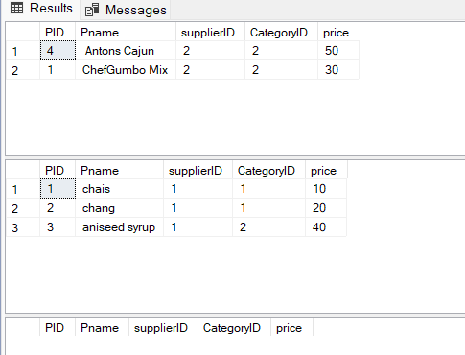

Correlated Subquery:

select p.PID,p.Pname,p.supplierID,p.price

from products p

where p.supplierID=(select b.supplierID from suppliers b

where supplierID='2');

**output:**

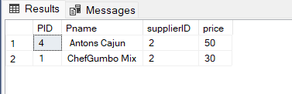

**Exists keyword:**

select Pname from products

where exists(select supplierID from suppliers where suppliers.supplierID=Products.CategoryID);

output:

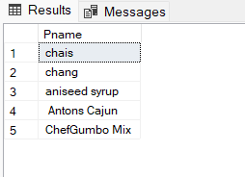

**NOT Exists keyword :**

select Pname from products

where not exists(select supplierID from suppliers where suppliers.supplierID=Products.CategoryID);

output:

